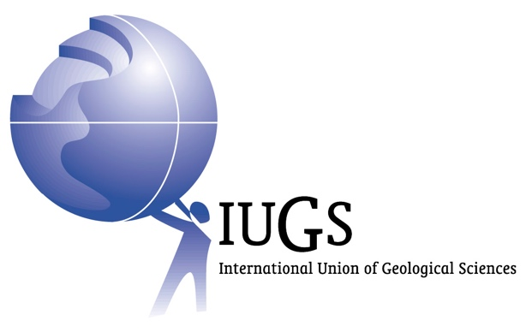

**The International Union of Geological Sciences (IUGS) announced the list of The Second 100 IUGS Geological Heritage Sites at the 37th International Geological Congress (IGC) in Busan, Republic of Korea.**

**The announcement was made by IUGS President John Ludden, Stanley Finney, IUGS Secretary General, and Asier Hilario chair of the International Commission on Geoheritage on August 27th during an special event of the 37th International Geological Congress.**

**More than 700 experts from 80 nations and 16 international organizations participated in this global endeavor, which consolidates the recognition of geological heritage by the IUGS.**

**More information:** [**www.iugs-geoheritage.org**](http://www.iugs-geoheritage.org)(available from August 26)

The announcement of the Second 100 IUGS Geological Heritage Sites was one of the main events of the second day of the 37th International Geological Congress (IGC). IGC is the main conference related to Earth Sciences, it is sponsored by and is the scientific forum of the IUGS. Every four years the IGC brings together an important part of the geological community from all over the world.

The announcement of the Second 100 IUGS Geological Heritage Sites consolidates this global initiative that started with the announcement of “The First 100” during the IUGS 60th anniversary event in 2022 in Zumaia (Basque Coast, Spain). The main goal of this collaborative program led by the IUGS is to give the highest recognition to those sites that are essential for the geological sciences.

The Second 100 IUGS Geological Heritage Sites, as with the First 100, receive IUGS recognition because they are the highest scientific value. They are the world’s best demonstrations of geologic features and processes. They are the sites of fabulous discoveries of the Earth and its history. They are sites that served to develop the science of geology. They are located worldwide, and they are geologically diverse. Recognition and visibility of the “Second 100” by IUGS can lead to their further appreciation, to their use as educational resources, and, most importantly, to their preservation.

The final selection of the “Second 100” was ratified by the IUGS Executive Committee on February 21, 2024. The Second 100 Geological Heritage Sites are distributed in 53 countries and represent nine disciplines. The list of the “Second 100” is attached.

“The Second 100” as well as the “First 100” are attractively illustrated and described in a coffee table book than can be downloaded and purchased on the website of the International Commission on Geoheritage. [www.iugs-geoheritage.org](http://www.iugs-geoheritage.org).

In Busan, Republic of Korea

2024. August 27th

The International Union of Geological Sciences

Contact for more information:

**Dr. Asier Hilario** / flysch@gipuzkoa.eus

Chair – IUGS International Commission on Geoheritage